The Walter Cade, Jr. Southwest Laymen Workshop
Registration and Housing Form
The Westin Hotel
12720 Merit Drive, Dallas, TX 75251
July 21-23, 2023
Please Note:
- All room occupants must be included on this Registration and Housing Form, including all children.
- Children 5 years old and older must have a Banquet Ticket.
- June 1st, 2023 is the deadline for submitting your funds and this completed form.
Payments are made to: The Texas Layman Group

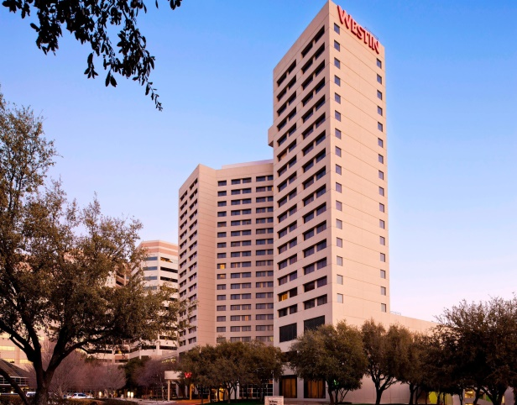

- Please mail check(s)/Money Order(s) and Form(s) to:
Alabama Baptist Laymen
Bernard Floyd, Jr.  2206 Roberta Drive Mobile, AL 36617 | Contact Brother Floyd at  Cell Phone (251-454-2005 Email: malcomb1956@yahoo.com

Name: |  |  | Phone:
Address: |  |  | Email:
City: |  |  | State: |  |  |  | Zip Code:
Church |  |  | Convention

Please check one Box:
Room Configuration | No. of Tickets | Registration Price | Hotel Designation
1 Person with 1 Bed | 1 Banquet Ticket | 1 Registration = $380.00 | Single
2 Persons with 1 Bed | 2 Banquet Tickets | 2 Registrations = $480.00 | Double
2 Persons with 2 Beds | 2 Banquet Tickets | 2 Registrations = $480.00 | Double/Double
3 Persons with 2 Beds | 3 Banquet Tickets | 3 Registrations = $580.00 | Double/Double
4 Persons with 2 Beds | 4 Banquet Tickets | 4 Registrations = $680.00 | Double/Double

List Room Occupants  M F |  | Pre-Order “T” Shirts (Enter Quantity for Each)
1.  M F |  | Small - N/A |  | XX Large - $15.00
2.  M F |  | Medium - $15.00 |  | XXX Large - $15.00
3.  M F |  | Large - $15.00 |  | XXXX Large - $18.00
4. |  | X Large - $15.00
Special Needs

Please place the appropriate amount in each blank space.
Extra Banquet Tickets at $60.00 per Ticket ______ and Your Total “T” Shirt Amount _________ equals the Total Amount Enclosed (Check or Money Order)

Remember this form is for Registration and Housing only. If you have any questions about Registration and Housing, please contact Brother Mckinney. Also, in the space labeled ‘List Room Occupants’ please list the names of persons and their Gender staying in that room, including children. All meals are included in the Registration price (including the Banquet Ticket). Additional Banquet Tickets may be purchased. Some instructors may ask for a small donation to cover the cost of producing their classroom materials.

The Walter Cade, Jr. Southwest Laymen Workshop
Souvenir Journal Ad Form

The Westin Hotel
12720 Merit Drive
Dallas,TX 75251
Pastors, Laymen and Auxiliaries of the Texas State Conventions this Souvenir Journal is used to advertise and promote churches, religious organizations, civic groups, businesses, elected governmental officials and individuals within our State to the churches and delegates of the Southwest Region. It is a wonderful opportunity to showcase the wealth of resources available in our State. You are encouraged to get as much of what is offered in our State communicated across the Southwest Region by way of Ads in the Souvenir Journal as possible. The people of Alabama, Arkansas, Kentucky, Louisiana, Mississippi,Tennessee and Texas will enjoy and get informed by your Ad in the Journal. Of course, the people of Texas will see it as well.
Please Note:
- All Ads MUST BE CAMERA READY. (Ready for print) No hand written Ads, Please
- If you need assistance with development of your Ad, contact Brother McKinney. See his contact info below.
- Email may be used to forward your Ad(s).
- June 1st, 2023 is the deadline or ASAP for submitting your Ad(s), funds and this completed form.
Payments are made to: The Texas Laymen Group
- Please mail check(s)/Money Order(s) and Form(s) to:
The Texas Laymen Group
c/o Bro. Walter McKinney 1227 Serenade Ln Dallas,TX 75241 | Contact Bro. Mckinney at  Cell Phone (214) 293-3386 Home Phone (214) 376-2705 Emailmckinney.walter@att.net

Please provide the following contact information for your Ad(s).
Name: |  |  | Phone:
Address: |  |  | Email:
City: |  |  | State: |  |  | Zip Code:

Please mail check(s)/Money Order(s) and Form(s) to:
The Texas Layman Group
c/o Bro Walter Mckinney 1227 Serenade Ln Dallas,TX 75241 | Contact Bro Mckinney at  Cell Phone (214) 293-3386 Home Phone (214) 376-2705 Email mckinney.walter@att.net
Please select your Ad preference by checking the appropriate box. (Camera Ready Ads Only – Please!)
Color Ad Prices
Back Cover |  | $350.00 |  | Color Ad with Photo
Inside Front Cover |  | $250.00 |  | Color Ad with Photo
Inside Back Cover |  | $250.00 |  | Color Ad with Photo
Full Page |  | $125.00 |  | Color Ad with Photo
Half Page |  | $70.00 |  | Color Ad with Photo
Black and White Ad Prices
Quarter Page |  | $50.00 |  | Black and White Ad - No Photo
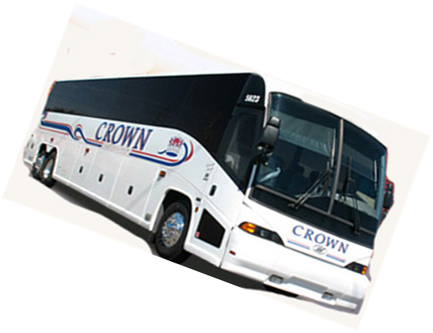
Please do not send Cash!

