History of the Certificate of Progress Program
The Certificate of Progress Program, organized at the Sunday School Publishing Board in 1937, was designed to produce qualified teachers that would lead church members into the twenty-first century.
Dr. Marshall A. Talley has been credited as the person that instituted the COP Program. In 1978, Dr. Amos Jones, Jr., undertook the leadership of the COP Program to take it to new heights.

COPP Objectives
- To increase biblical knowledge
- To create an understanding of the Baptist Church
- To provide an educational structure that will develop candidates qualified for teaching and leadership position
- To provide incentives for the candidates to complete the program
- To produce trained church leaders

Southeast District State Convention

Christian Education Certified Dean

Rev. Edward Milner
Dean Of CLS

Ms. Truenetta C. Meadows
Dean Of Record

Rev. Darryl President

~~~~~~~~~~~~~~~~~~~~~~~~~~~
~~~~~~~~~~~~~~~~~~~~~~~~~~~

CLS
Christian Leadership School

COPP
Certificate Of Progress Program

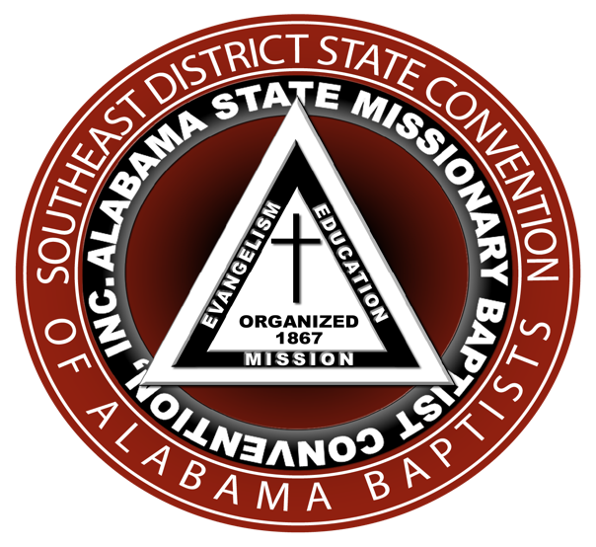
Christian Leadership School
(CLS)
Certificate Of Progress Program
(COPP)

The Certificate of Progress Program is a highly structured Christian Leadership School of the National Baptist Convention, USA, Inc. The program is designed to produce qualified church leaders with the capability to lead church members of the NBC USA, Inc. in and beyond the 21st century. The Sunday School Publishing Board administers programs of study that support the NBC, USA, Inc. The Division of Christian Education Accreditation and Credentials’ (DCEAC) Office provides oversight of Christian Leadership Schools (CLS).

How Do I Begin?

Contact the Dean of Record to assist you through this process.

Complete and submit the official Form 12 Admissions Application

Submit a $15.00 Application Fee with Application

Subscribe to the Christian Education Informer Magazine @ a $30.00 annual fee

Submit completed form and required fees payable to the Sunday School Publishing Board (SSPB)

Want To Teach?

In order to be certified to teach in a certified school, an individual must have:

First Certificate Of Progress

#2023 Creative Ways of Teaching

#9008 Public Speaking

Form 5 Application for Certification or Instructor

Current Subscription to the Christian Education Informer

Appropriate Fees

The SSPB will also take seminary and/or college equivalent for all courses. A transcript will be needed. (Your Dean of Record will assist you with this process)

WANT TO BE A DEAN?

The first requirement is that you MUST complete all four Phases of the COPP!

The Certificate Of Progress Program
course offerings per phase are as follows:

PHASE 1 COURSES

1001 Introduction to the Bible
1004 Effective Bible Reading
1007 Survey of the Old Testament
1072 Survey of the New Testament
2011 Baptist Doctrine
6021 Spiritual Formation

PHASE 2 COURSES

1075 The Synoptic Gospels
2007 Christian Stewardship
3008 Theology and History of Christianity
4012 The Doctrine of the Holy Spirit
7024 Discovering Your Spiritual Gifts
9004 Writing Techniques I

PHASE 3 COURSES

1079 Survey Of John
1089 Survey of Roman
3007 History of Baptists
7005 Christian Evangelism
7010 Introduction to Discipleship
9005 Writing Techniques II

PHASE 4 COURSES

1112 Survey of Revelation
2015 Foundation of Christian Education
6013 Organizing the Church for Christian Education
8035 The African-American Church and Social Justice
8066 Christianity and Contemporary Issues
9024 The Computer in the Life of the Church

